**To find out the status (prime and composite) of each number available in the given range**

* **Code** **Snippet:**

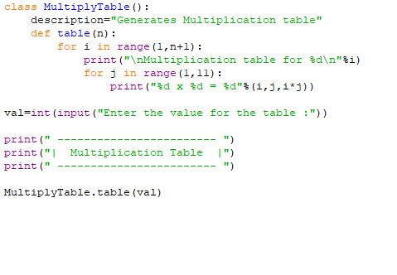

* **Output:**

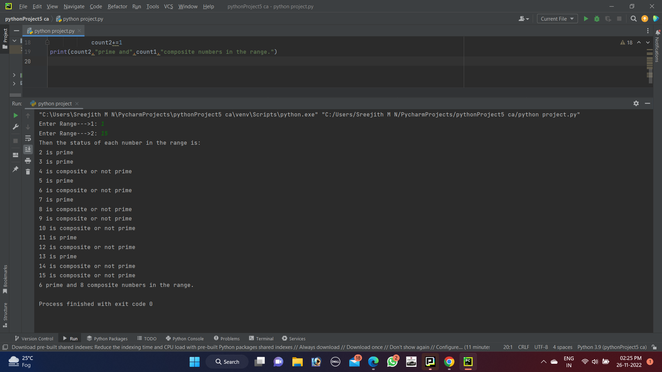

* **Output:**

